1. The canonical expression for this one is:

W=(~X&Z) | (Y&Z)

The gate-level logical circuit is: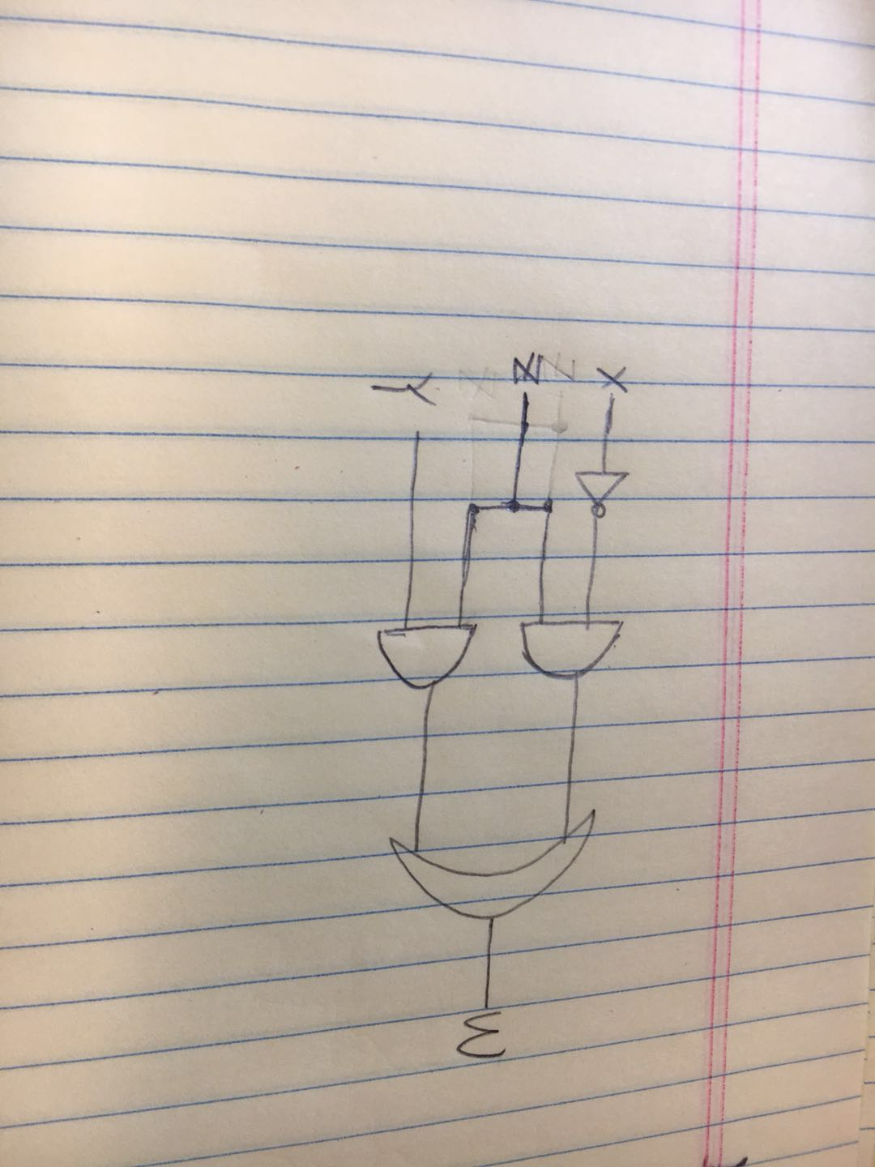

1. The Boolean expression for this circuit is

F= (A&(B|~C)) | (B&(C|~D)) | (B&D)

The truth table for this one is:

A B C D F

0 0 0 0 0

0 0 0 1 0

0 0 1 0 0

0 1 0 0 1

1 0 0 0 1

0 0 1 1 0

0 1 0 1 1

1 0 0 1 1

0 1 1 0 1

1 0 1 0 0

1 1 0 0 1

0 1 1 1 1

1 1 0 1 1

1 1 1 0 1

1 0 1 1 0

1 1 1 1 1

1. a) Truth table for O as a Boolean function of Sx, Sy, and Sz

Sx Sy Sz O

0 0 0 0

1 0 0 0

0 1 0 0

0 0 1 1

0 1 1 0

1 0 1 0

1 1 0 1

1 1 1 0

b) O= (Sx & Sy & ~Sz)|(~Sx&~Sy & Sz)

c)